**WEEK-10 COLLECTION LIST**

**NAME : ENIYA.B.A**

**CLASS : CSE-B**

**ROLL NO : 230701085**

**SUBJECT : Object Oriented Programming Using Java**

**SUB CODE : CS23333**

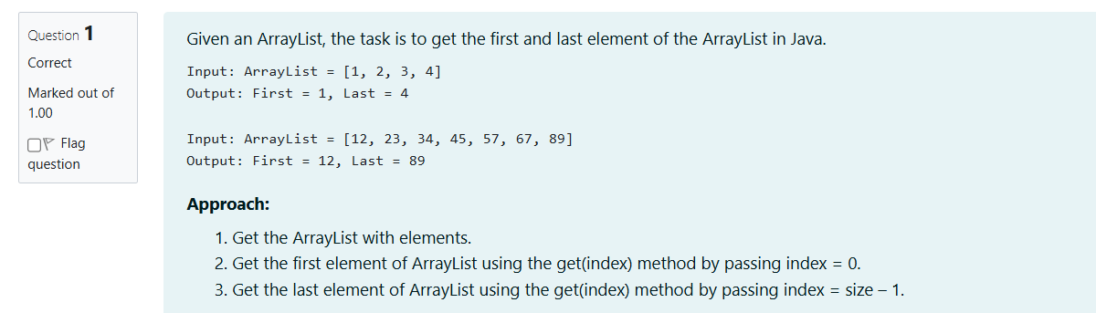

CODE:

import java.util.ArrayList;

import java.util.Scanner;

public class Main {

public static void main(String[] args) {

// Create a scanner to read input from the user

Scanner scanner = new Scanner(System.in);

int n = scanner.nextInt();

// Initialize an ArrayList to hold the user input

ArrayList<Integer> list = new ArrayList<>();

for (int i = 0; i < n; i++) {

int element = scanner.nextInt(); // Read each element

list.add(element); // Add it to the ArrayList

}

// Display the ArrayList (for test purposes)

System.out.println("ArrayList: " + list);

// Get and print the first and last elements

printFirstAndLast(list);

// Close the scanner

scanner.close();

}

// Method to print first and last element of the ArrayList

public static void printFirstAndLast(ArrayList<Integer> list) {

if (list.isEmpty()) {

System.out.println("The list is empty.");

} else {

int first = list.get(0); // Get the first element

int last = list.get(list.size() - 1); // Get the last element

System.out.println("First : " + first + ", Last : " + last);

}

}

}

OUTPUT:

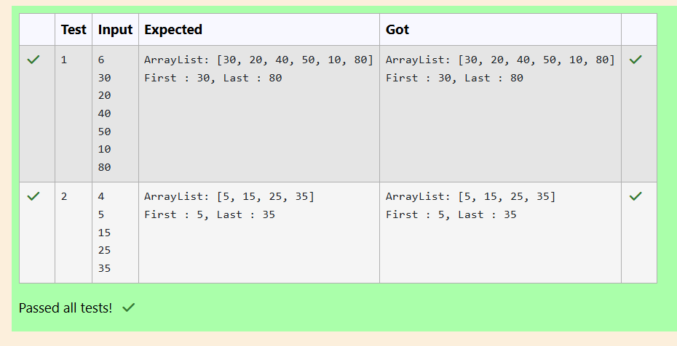

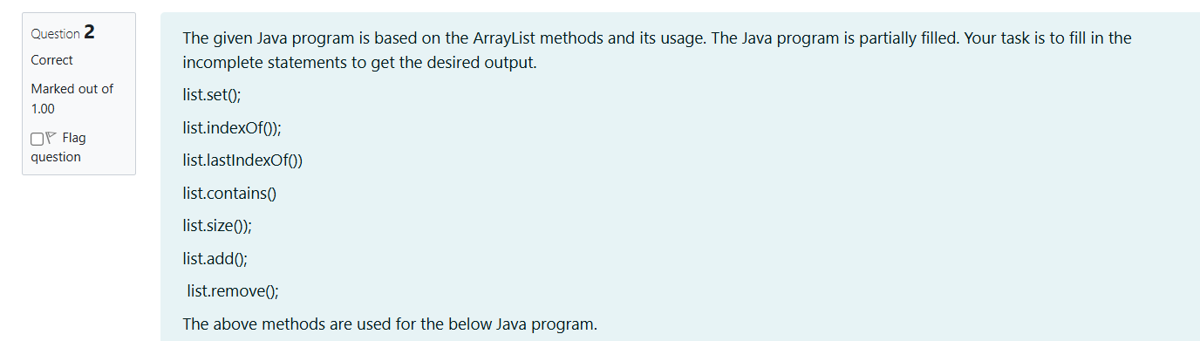

CODE:

import java.util.ArrayList;

import java.util.Scanner;

public class Prog {

public static void main(String[] args) {

// Create a scanner object to read input from the user

Scanner sc = new Scanner(System.in);

// Read the number of elements to be added in the ArrayList

int n = sc.nextInt();

// Create an ArrayList of Integer type

ArrayList<Integer> list = new ArrayList<Integer>();

// Read n elements from the user and add them to the ArrayList

for (int i = 0; i < n; i++) {

list.add(sc.nextInt());

}

// Printing the initial ArrayList

System.out.println("ArrayList: " + list);

// Replacing the element at index 1 with 100

if (list.size() > 1) {

list.set(1, 100); // Replace element at index 1

}

// Getting the index of the first occurrence of 100

System.out.println("Index of 100 = " + list.indexOf(100));

// Getting the index of the last occurrence of 100

System.out.println("LastIndex of 100 = " + list.lastIndexOf(100));

// Check whether 200 is in the list or not

System.out.println( list.contains(200)); // Output: false

// Print ArrayList size

System.out.println("Size Of ArrayList = " + list.size());

// Inserting 500 at index 1

list.add(1, 500); // Insert 500 at index 1

// Removing an element from position 3

if (list.size() > 3) {

list.remove(3); // Remove element at index 3

}

// Print the modified ArrayList

System.out.println("ArrayList: " + list);

// Close the scanner

sc.close();

}

}

OUTPUT:

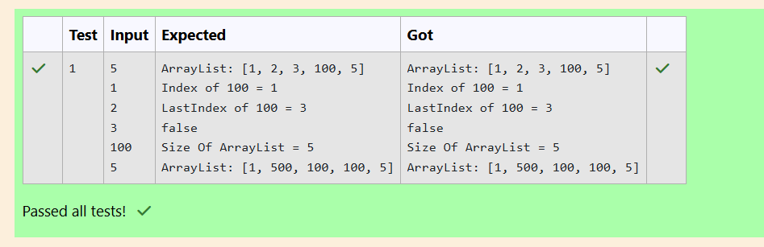

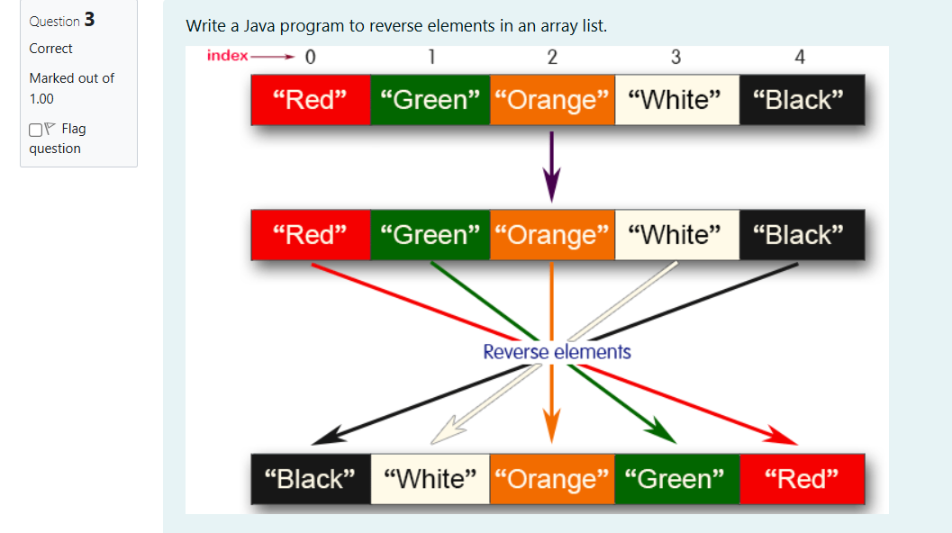

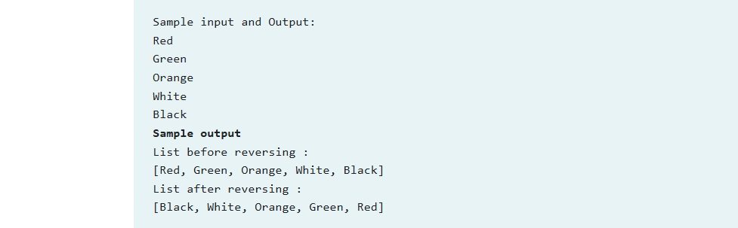

CODE:

import java.util.ArrayList;

import java.util.Collections;

import java.util.Scanner;

public class Main {

public static void main(String[] args) {

Scanner scanner = new Scanner(System.in);

// Create an ArrayList of Strings

ArrayList<String> list = new ArrayList<>();

// Input the number of elements

int n = scanner.nextInt();

scanner.nextLine(); // Consume the newline character after the integer input

// Read each element and add it to the ArrayList

for (int i = 0; i < n; i++) {

String element = scanner.nextLine();

list.add(element);

}

// Print the list before reversing

System.out.println("List before reversing :");

System.out.println(list);

// Reverse the ArrayList using Collections.reverse() method

Collections.reverse(list);

// Print the list after reversing

System.out.println("List after reversing :");

System.out.println(list);

scanner.close();

}

}

OUTPUT:

